Press Release
25.05/2026
Donegal County Council Are Pleased To Announce The Publication Of The Options Reports For The Four Greenway Projects

THE CARRIGANS TO LIFFORD GREENWAY
THE THREE TREES TO CARNDONAGH GREENWAY
THE BUNCRANA TO CARNDONAGH GREENWAY
THE AILT AN CHORRÁIN TO LETTERKENNY GREENWAY

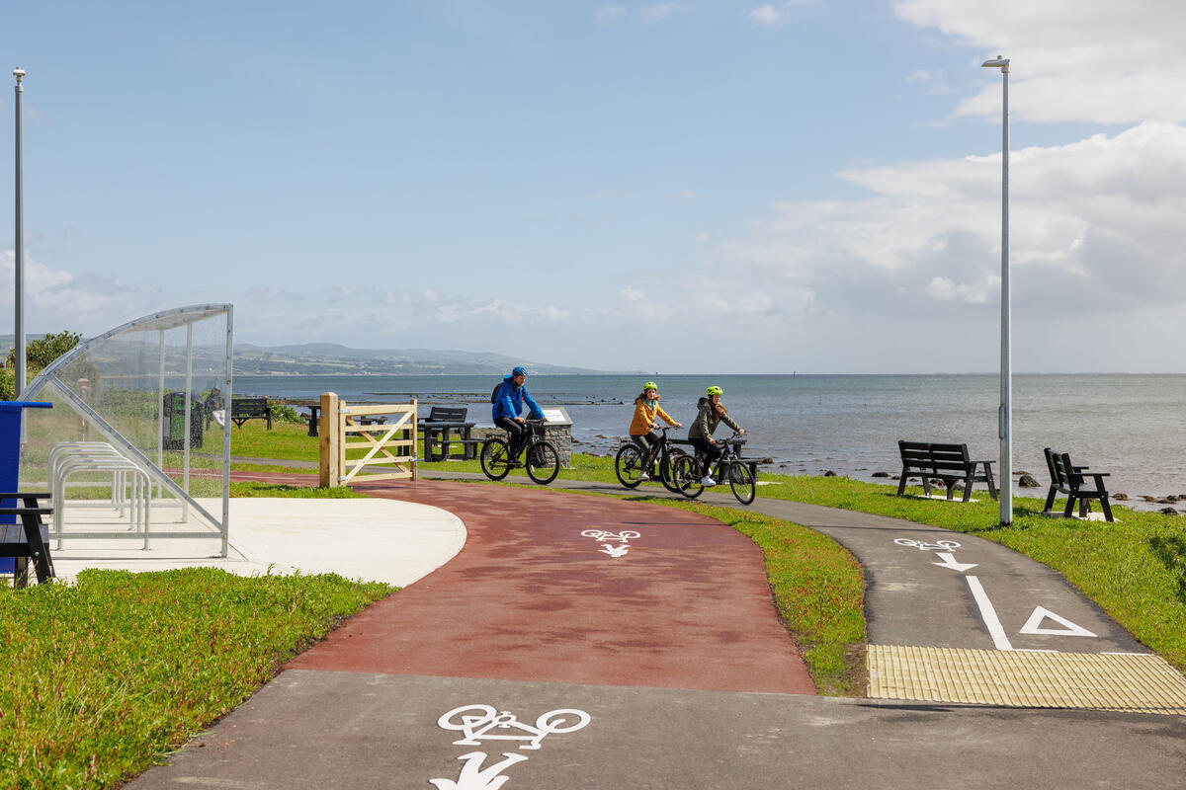
Photo of the Derry to Three Trees Greenway

The Phase 2 Options Selection process for four greenway projects namely the Carrigans to Lifford Greenway, Three Trees to Carndonagh Greenway, Buncrana to Carndonagh Greenway and Ailt an Chorráin to Letterkenny Greenway projects has now been completed by Donegal County Council.

The Preferred Route Corridor has been identified for each greenway project and its selection process is detailed within the relevant Options Report for each project. A summary of each project’s Preferred Route Corridor is provided in the following fact sheets.

The Options Report for the projects will be available for viewing from Monday 25th May 2026 to Friday 12th June 2026 at the locations and opening hours specified on the fact sheets and can be viewed on their respective project websites. An interactive map of the Preferred Route Corridor will also be available on each project’s website.

At this early stage in project development, the Preferred Route Corridor for each project indicates a wide corridor in which a narrow greenway route is proposed to be developed. Most of the land included within the Preferred Route Corridor will not be affected by the Preferred Route of the greenway within it, and every effort will be made by Donegal County Council to minimise impacts to landowner interests.

Should members of the public wish to discuss any of the projects, they can contact the National Roads Office by telephone on 074 972 4500 or by post at:

Greenways Capital Projects
Donegal County Council
County House
Lifford
Co. Donegal
F93 Y622

 |  |  |  |  | 

Preferred Route Corridor |  |  |  | 
Description:
The Carrigans to Lifford Greenway Preferred Route Corridor is approximately 18km long between Lifford and the border with Northern Ireland near Carrigans. At the Northern Ireland border, the corridor will be designed to integrate with the Foyle Valley Greenway, providing onward connectivity to Derry. The corridor includes opportunities to connect the settlements of Lifford, Rossgier, Coolatee, Porthall, St Johnston and Carrigans along with the potential reuse of the historic railway corridor between the townland of Carrickmore and the border. The typical width of the corridor is 300m, widening around Lifford, Porthall, St Johnston and Carrigans to up to a maximum of 1.8km to provide flexibility to route the greenway to minimise potential landowner impacts and avoid identified sensitive environmental areas. The area surrounding Clonleigh Graveyard has also been excluded from the corridor to avoid potential impacts on the historic site.

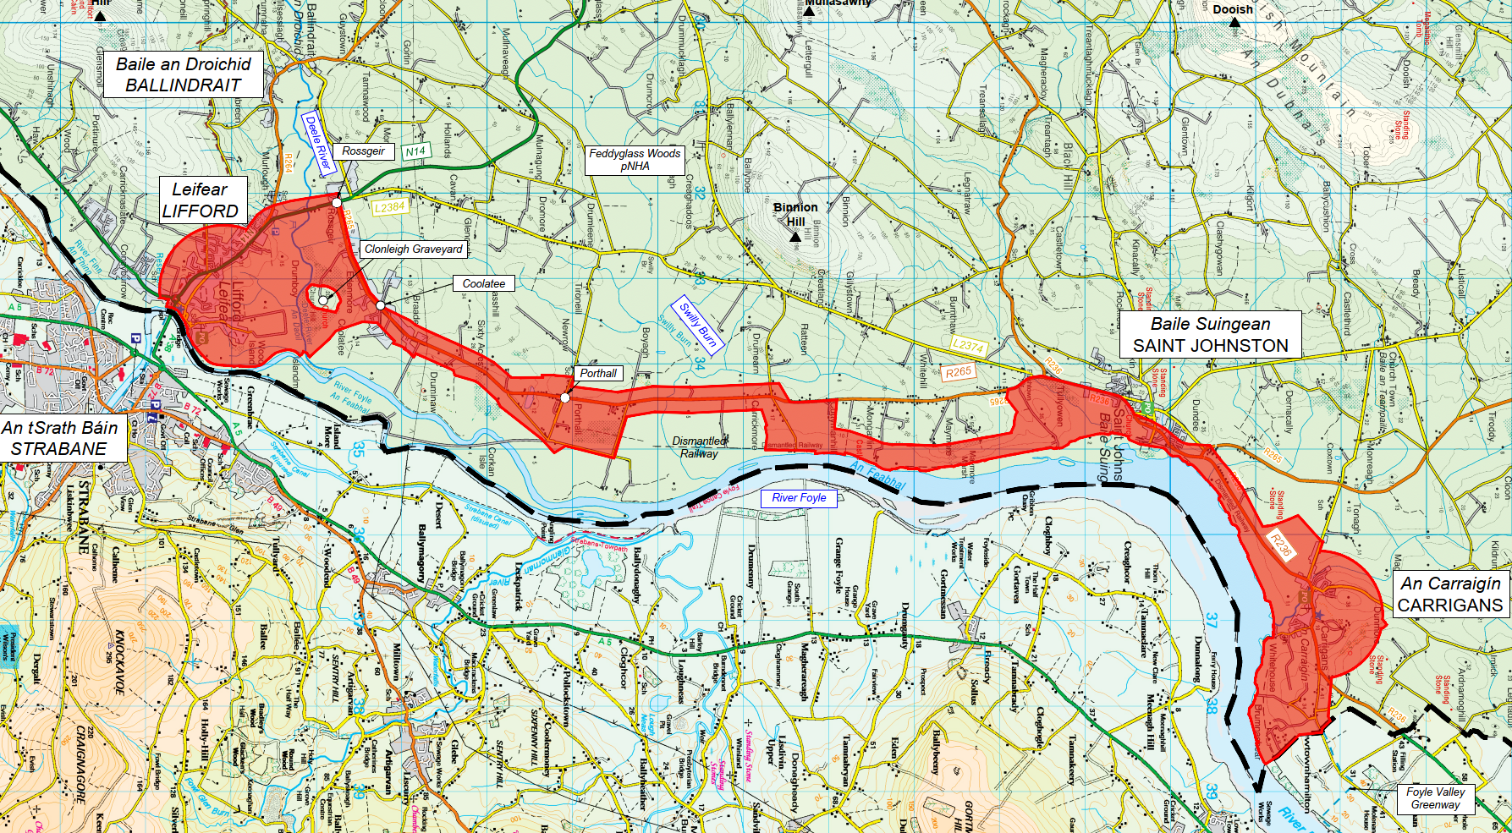
Where and when the Options Report will be available for inspection:
From Monday 25th May 2026 to Friday 12th June 2026 at:
Donegal County Council
County House
Lifford
F93 Y622
Opening Hours: Monday to Friday 9:00am to 4.00pm
Project website:
The Options Report will also be available on the project website along with an interactive map of the Preferred Route Corridor at:
www.carrigansliffordgreenway.ie

Preferred Route Corridor |  |  |  | 
Description:
The Three Trees to Carndonagh Greenway Preferred Route Corridor extends approximately 41km and provides scenic coastal alignment commencing at Three Trees, where it connects with the Muff to Three Trees Greenway, facilitating onward cross-border connectivity into Derry City as well as local facilities within Muff. From Three Trees, the corridor extends to include towns/villages such as Quiqleys Point, Moville, Greencastle, Gleneely before terminating in Carndonagh. At Carndonagh, the corridor integrates with the proposed Buncrana to Carndonagh Greenway, to create a strategic link between the two schemes and form part of a wider Inishowen active travel network. The corridor has an approx. minimum width of 300m and an approx. maximum width of 1.4km. The typical width of the corridor is approx. 700m.
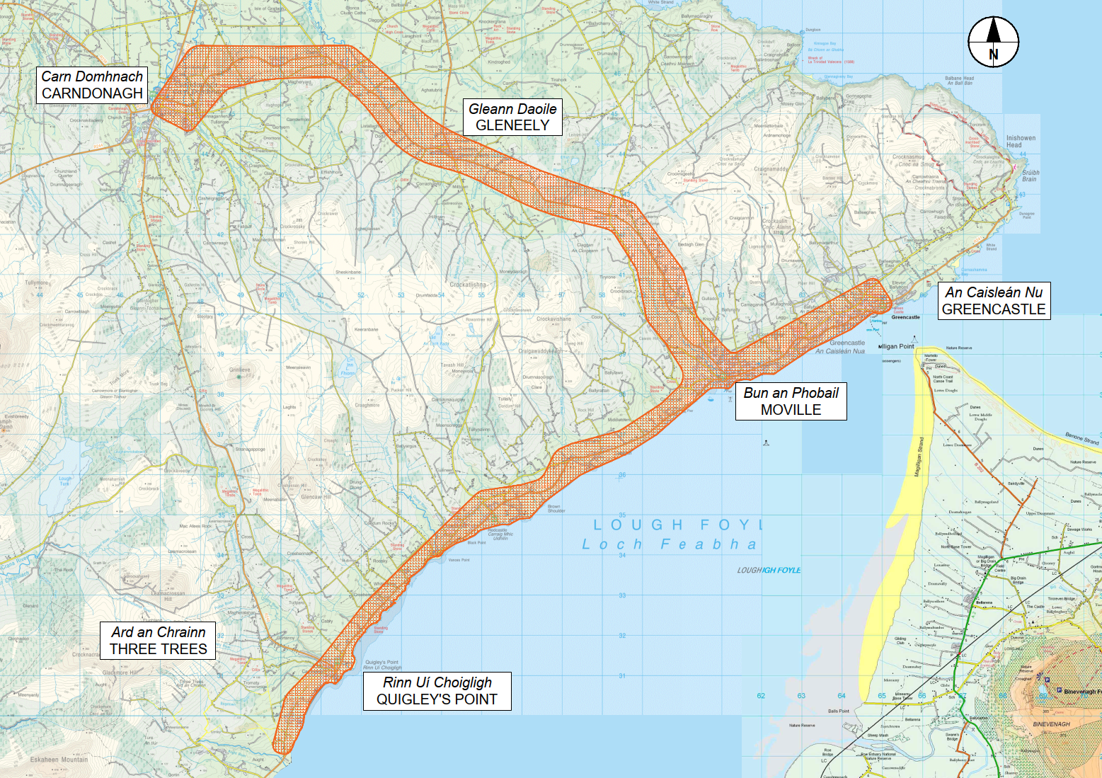
Where and when the Options Report will be available for inspection:
From Monday 25th May 2026 to Friday 12th June 2026 at:
Carndonagh Public Services Centre
Malin Road
Carndonagh
F93 YV1N
Opening Hours: Monday to Friday 9:00am to 4.00pm
Project website:
The Options Report will also be available on the project website along with an interactive map of the Preferred Route Corridor at:
www.threetreescarndonaghgreenway.ie
Preferred Route Corridor |  |  |  |  | 
Description:
The Buncrana to Carndonagh Greenway Preferred Route Corridor is approximately 30km and extends from Buncrana to Carndonagh, broadly following the route of the R238 regional road and the historic Londonderry & Lough Swilly Railway. The corridor commences in Buncrana and includes towns/villages such as Drumfries, Clonmany and Ballyliffin, before terminating in Carndonagh. The corridor integrates with the proposed Three Trees to Carndonagh Greenway, creating a strategic link between the two schemes and forming part of a wider Inishowen active travel network. The corridor has an approx. minimum width of 20m (avoiding Umrycam Bog National Heritage Area) and an approx. maximum width of 1.5km. The typical width of the corridor is approx. 700m.
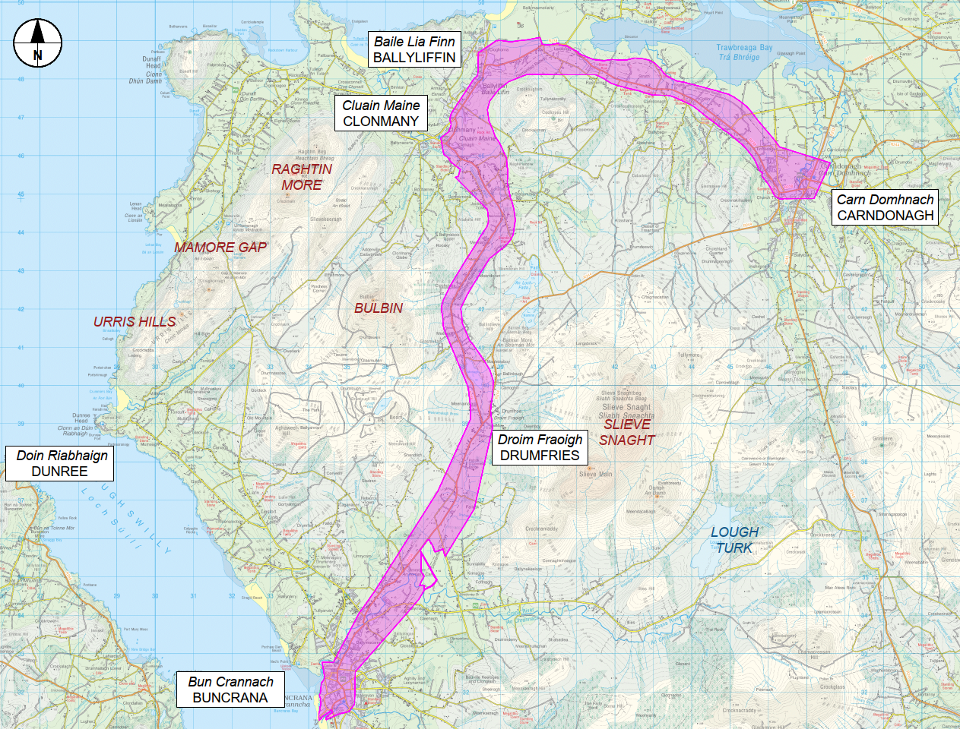
Where and when the Options Report will be available for inspection:
From Monday 25th May 2026 to Friday 12th June 2026 at:
Buncrana Library  St Marys Road  Buncrana  F93 YK68  Opening Hours:  9:30am – 5:30pm (Tuesday, Thursday and Friday)  12:30pm – 8:30pm (Wednesday)  10:00am to 2.30pm (Saturday) (Closed on 30th May) |  |  | Carndonagh Public Services Centre  Malin Road  Carndonagh  F93 YV1N  Opening Hours: Monday to Friday 9:00am to 4.00pm
Project website:
The Options Report will also be available on the project website along with an interactive map of the Preferred Route Corridor at:
www.buncranacarndonaghgreenway.ie

Preferred Route Corridor |  |  |  |  | 
Description:
The Ailt an Chorráin to Letterkenny Greenway Preferred Route Corridor is approximately 100km in length, stretching from An Clochán Liath to Letterkenny, mostly following along the route taken by the historic railway. The corridor commences at the pier in Ailt an Chorráin and generally follows the coast road before connecting with the existing Railway Walk. From there, it links to An Clochán Liath, broadly following the R259 and encompassing key areas around Loch Míle and the town. Beyond Ailt an Chorráin, the corridor extends to include towns/villages such as Croithlí, Dobhar, Gaoth Dobhair, An Fál Carrach, Dunfanaghy, Portnablagh, An Craoslach (Creeslough), An Tearmann, Glenswilly, Newmills before terminating in Letterkenny. The width of the corridor is generally around 500 metres but varies depending on local conditions. In some areas, it narrows to approximately 50 metres in width to minimise potential impacts on environmentally sensitive sites, while in other locations, such as near An Fál Carrach, it can extend up to 3.8 kilometres in width to provide flexibility for connecting to the existing Ailt an Chorráin Railway Walk (Muckish).
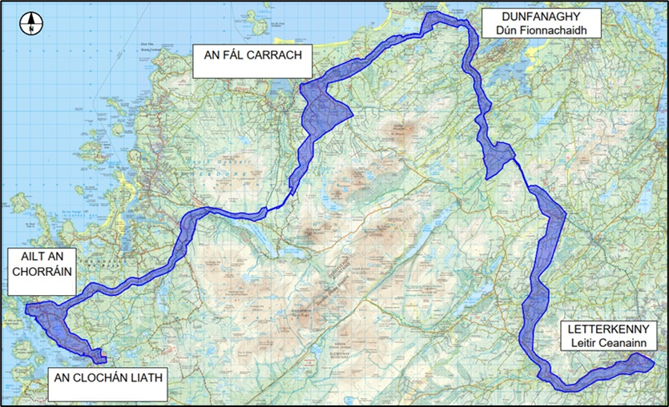
Where and when the Options Report will be available for inspection:
From Monday 25th May 2026 to Friday 12th June 2026 at:
Letterkenny Public Services Centre  Neil T. Blaney Road  Letterkenny  F92 TNY3  Opening Hours: Monday to Friday 9:00am to 4.00pm |  |  | An Clochán Liath Public Services Centre  Bóthar Ghaoth Dobhair  An Clochán Liath  F94 H4CF  Opening Hours: Monday to Friday 9:00am to 4.00pm
Project website:
The Options Report will also be available on the project website along with an interactive map of the Preferred Route Corridor at:
www.burtonportletterkennygreenway.ie

